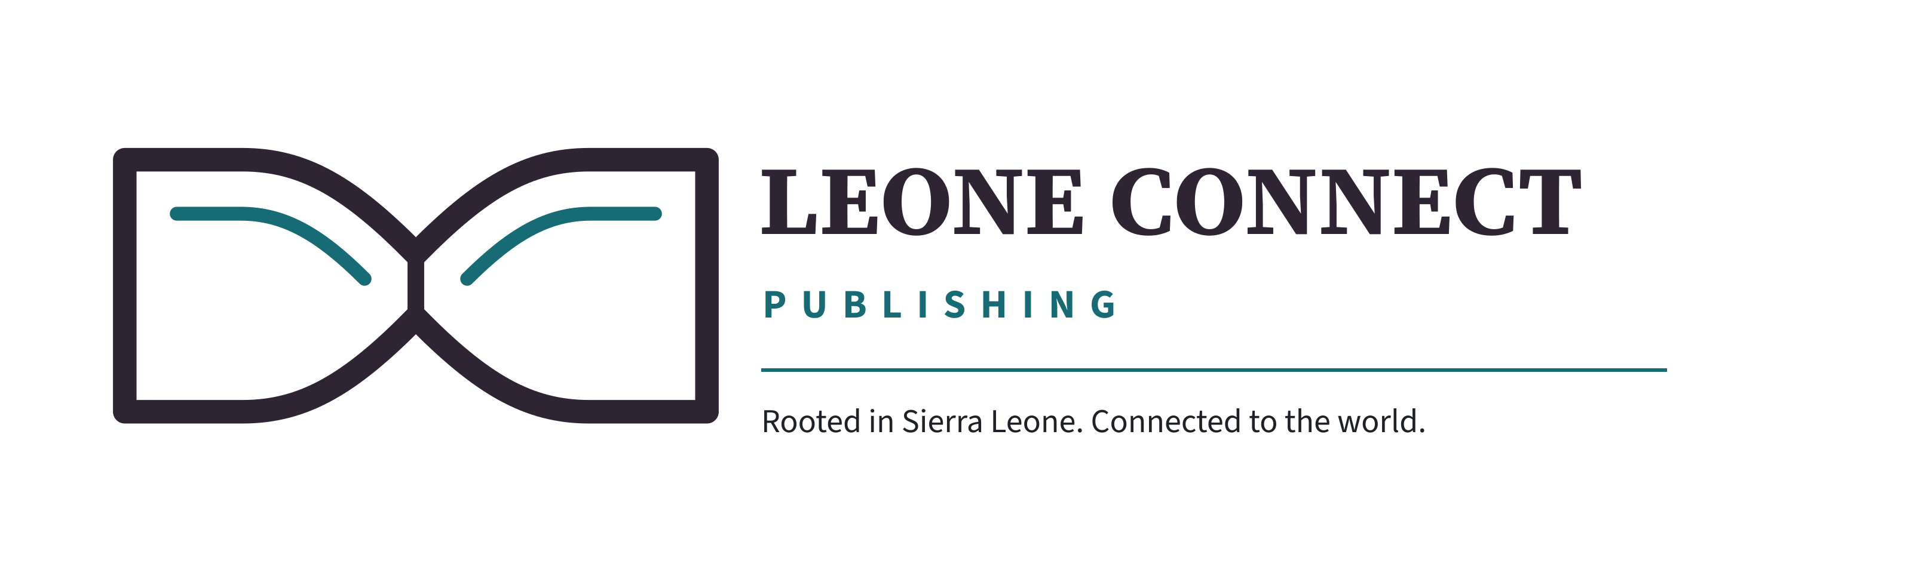
PUBLISHER FACTSHEET
Leone Connect Publishing
Leone Connect Publishing is an independent Sierra Leonean publishing house, rooted in Sierra Leone and connected to the world.

At a glance
Publisher: Leone Connect Publishing
Position: Independent Sierra Leonean publishing house
Operating form: Independent, unincorporated publishing imprint
Website: leoneconnect.com
Media Centre: leoneconnect.com/media/

Publishing programme
Nonfiction: Ideas, education, public life and civic thought
Literature: Fiction, essays and creative work
Poetry and young readers: Poetry, learning and books for younger audiences
Entertainment and media: Selected cultural, audio-visual and media projects

Current public title
Title: THE 5C THEORY
Author: Bhai-Dhawa Sesay
Publication state: Forthcoming - no public price or sales availability is stated

Approved boilerplate
Leone Connect Publishing is an independent Sierra Leonean publishing house whose programme spans nonfiction, ideas and education; literature; poetry and young readers; and selected entertainment and media projects. Its publishing platform connects catalogue records, authors, insights, learning resources, rights, submissions, media and Leone Connect Dispatch through one governed digital system.

Media enquiries
Interview, quotation, review-copy and additional-material requests should use the secure form at leoneconnect.com/contact/?enquiry=author#lcp-contact-form. No participation, permission, licensing or availability is implied by a request.

